 

# UNIVERSITY INSTITUTE OF COMPUTING

**PROJECT REPORT ON**

## DESIGNING A FLYER ON DOBE PHOTOSHOP

Program name**:** BCA

Subject name/Code: Desktop Publishing(23CAP-204)

## Submitted by: Submitted to:

**Name: ENANG E-E. Jnr. Name: Mrs. Pardeep Kaur UID: 23BCA10758**

**Section: BCA- 9(A)**

# INTRODUCTION TO ADOBE PHOTOSHOP

* Adobe Photoshop is a powerful image editing software that enables users to create, enhance, and manipulate photos and graphics with precision. It features a layered workflow, allowing for non-destructive edits, and offers a wide range of tools including selection tools, brushes, adjustment layers, and filters. Users can add and customize text, apply various effects, and use masking techniques for detailed editing. With a user-friendly interface, beginners can quickly learn basic operations like cropping and resizing, while more advanced users can explore intricate design projects. Numerous online resources, including tutorials and courses, make it accessible for anyone looking to enhance their creative skill.

# AIM:

* Create a visually appealing flyer in Adobe Photoshop by designing adding sections for menu items, incorporating images, and ensuring clear text and graphics for a polished final project.

# TOOLS USED:

* Rectangle Tool
* Text Tool
* Move Tool
* Layer Styles
* Brush Tool
* Shape tool
* Marquee Tool
* Image Adjustment Tools
* Guides and Rulers
* Crop Tool

# PROCESS:

* Open photoshop and create a new document with the desired dimensions.

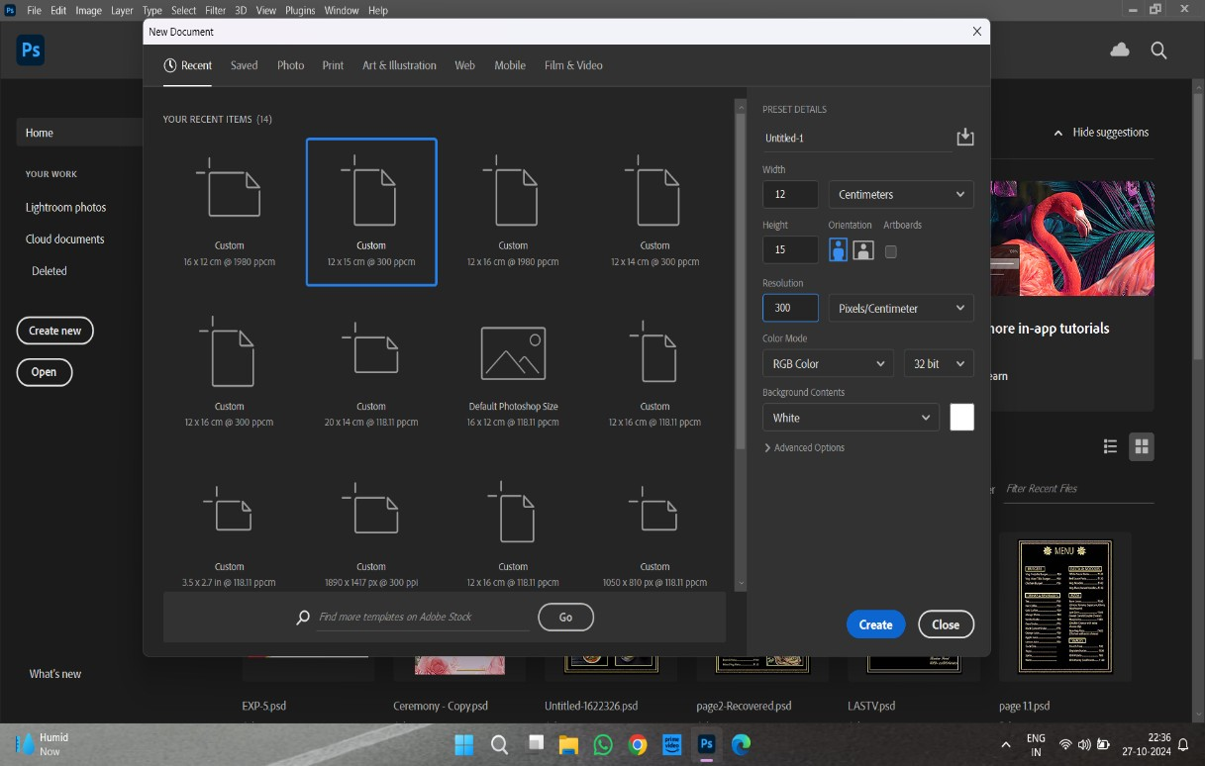

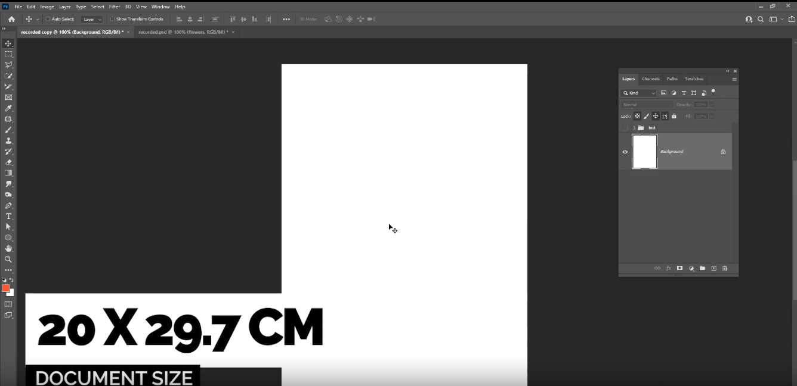

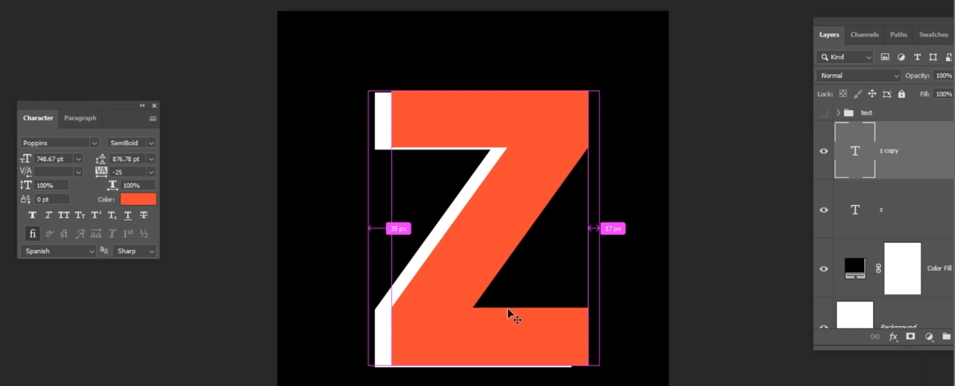

* Use the text tool and Write a letter and edit its properties.
* Create another layer copied from the above layer edit the properties and resize as per your design.

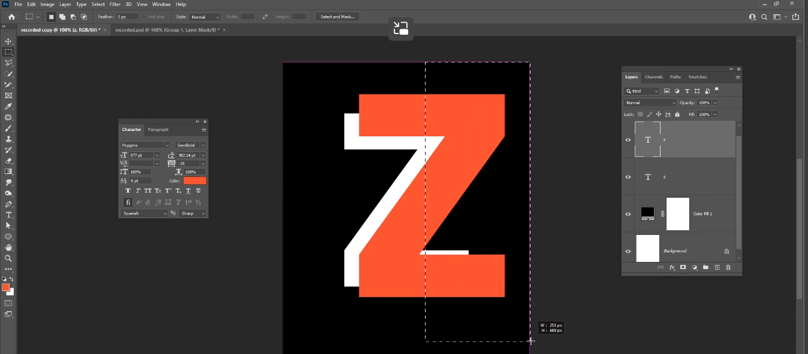

* Using the gradient tool highlight area u wish to Layer mask on Z copy.
* On the Z layer do an inverted mask and set the background color to black.
* Insert image to cover both masks as a new layer Using the Alt and arrow pointing Z copy it inserts the Z as its background.
* 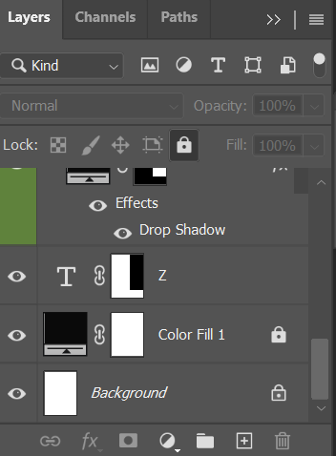

Layer Sections showing

* Z.
* Properties of Z copy
* Background.

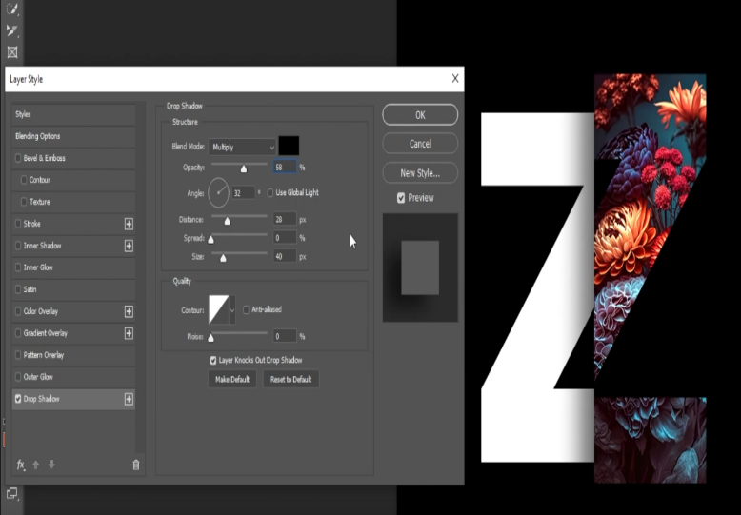

* Layer Style of Z copy group such as:
* Shadow
* Distortion
* Noise

h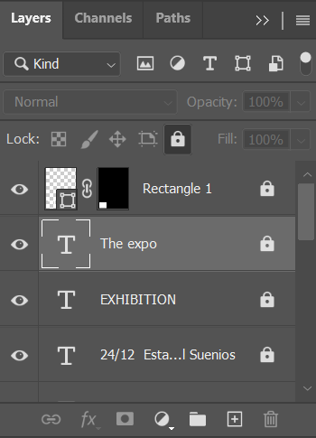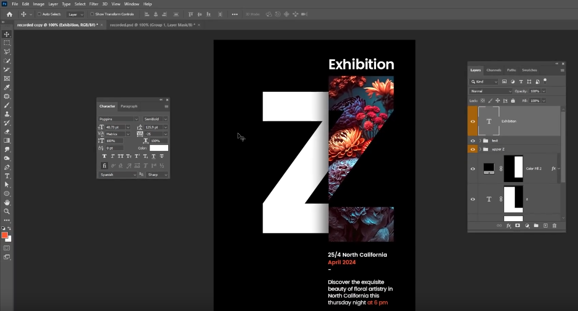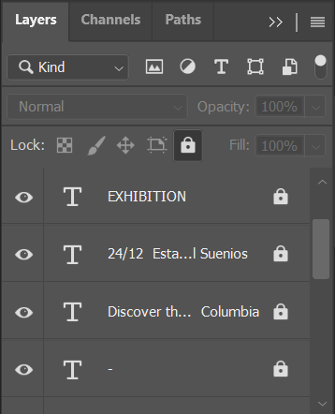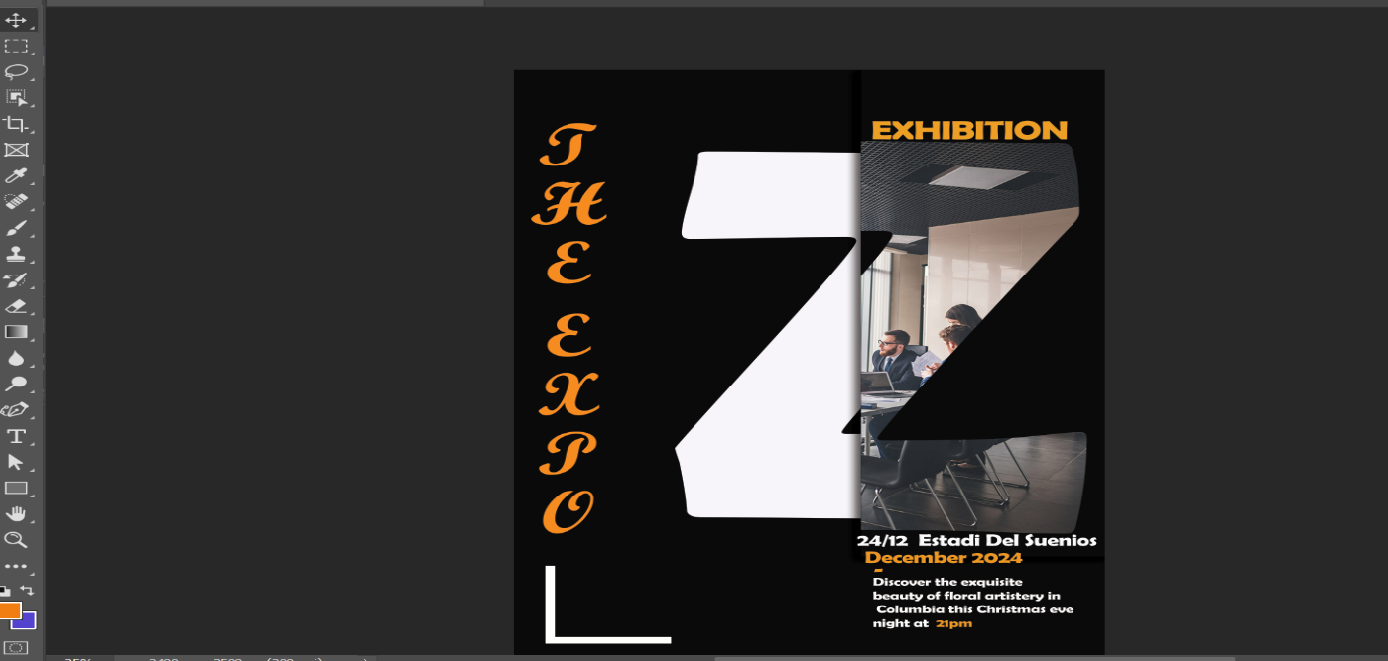

Layers

* Layers Rectangle 1 and 2 which properties which were masked.
* Exhibition done Using Text tool
* The Expo done same but text has been put vertically
* The Date and Event Details Paragraph.

Layers

* Z group denoted with Orange and also its masked features.
* Details of Event and divider layers.
* Rectangles masked to make angle at bottom of design.
* Use Move Tool to reposition elements, ensuring everything is well-aligned and evenly spaced.
* Save your project file (PSD) for future edits, then export the final version as a PDF of high-resolution image for printing.

# FINAL DESIGN

